**Sequences of Operations and the RENAME Operation**

The relations shown in the results of select and project operations do not have any names. In general, for most queries, we need to apply several relational algebra operations one after the other. Either we can write the operations as a single relational algebra expression by nesting the operations, or we can apply one operation at a time and create intermediate result relations.

In the latter case, we must give names to the relations that hold the intermediate results.

For example, to retrieve the first name, last name, and salary of all employees who work in department number 5, we must apply a SELECT and a PROJECT operation.

We can write a single relational algebra expression, also known as an in-line expression, as follows:

πFname, Lname, Salary(σDno=5(EMPLOYEE))

Figure 8.2(a) shows the result of this in-line relational algebra expression.

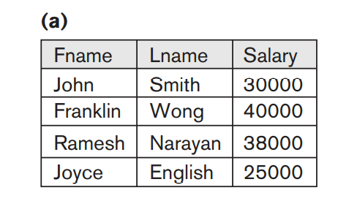

Alternatively, we can explicitly show the sequence of operations, giving a name to each intermediate relation, and using the assignment operation, denoted by ← (left arrow), as follows:

DEP5_EMPS ← σDno=5(EMPLOYEE)

RESULT ← πFname, Lname, Salary(DEP5_EMPS)

To rename the attributes in a relation, we simply list the new attribute names in parentheses, as in the following example:

TEMP ← σDno=5(EMPLOYEE)

R(First_name, Last_name, Salary) ← πFname, Lname, Salary(TEMP)

These two operations are illustrated in Figure 8.2(b).

If no renaming is applied, the names of the attributes in the resulting relation of a

SELECT operation are the same as those in the original relation and in the same

order. For a PROJECT operation with no renaming, the resulting relation has the

same attribute names as those in the projection list and in the same order in which

they appear in the list.

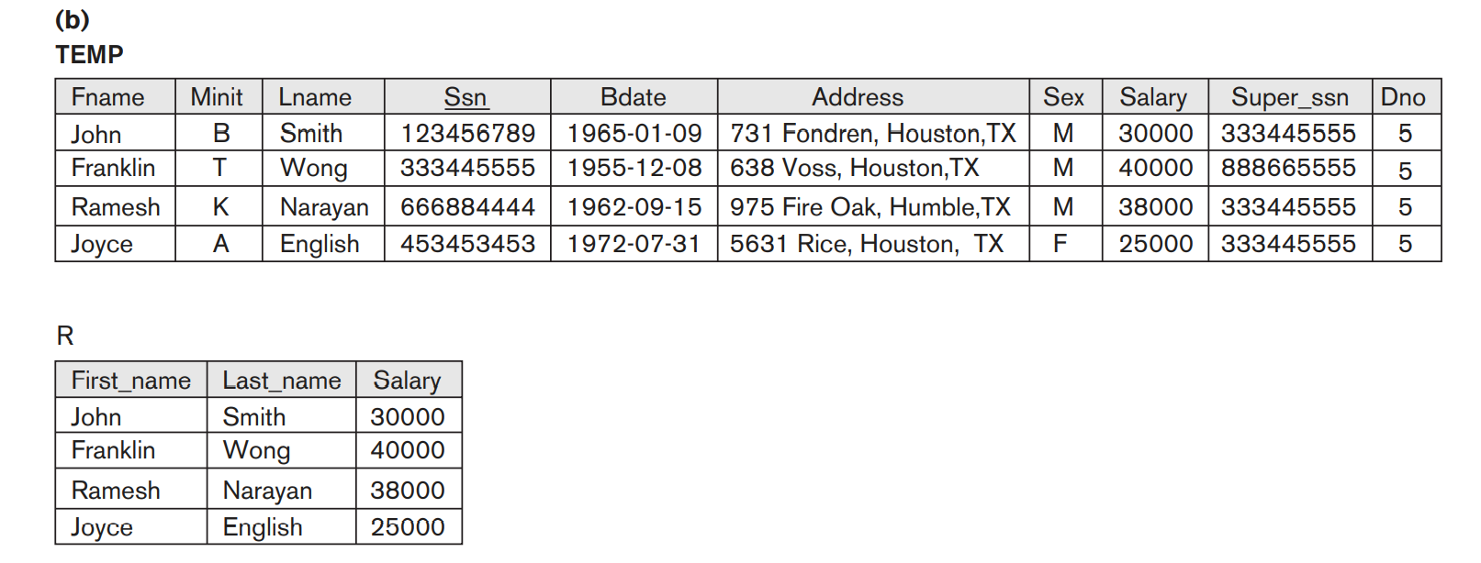

We can also define a formal RENAME operation—which can rename either the relation name or the attribute names, or both—as a unary operator. The general

RENAME operation when applied to a relation R of degree n is denoted by any of the

following three forms:

ρS(B1, B2, ... , Bn)(R) or ρS(R) or ρ(B1, B2, ... , Bn)(R)

where the symbol ρ (rho) is used to denote the RENAME operator, S is the new relation name, and B1, B2, … , Bn are the new attribute names.

The first expression renames both the relation and its attributes, the second renames the relation only, and the third renames the attributes only.

If the attributes of R are (A1, A2, … , An) in that order, then each Ai is renamed as Bi.

In SQL, a single query typically represents a complex relational algebra expression.

Renaming in SQL is accomplished by aliasing using AS, as in the following example:

SELECT E.Fname AS First_name, E.Lname AS Last_name, E.Salary AS Salary

FROM EMPLOYEE AS E WHERE E.Dno=5;